PHYS 212 PreLab 2 Name ______________ ID_____________________
• The direction of an electric field at a given point is defined as the direction of the force a positive test charge would experience if placed at that point.
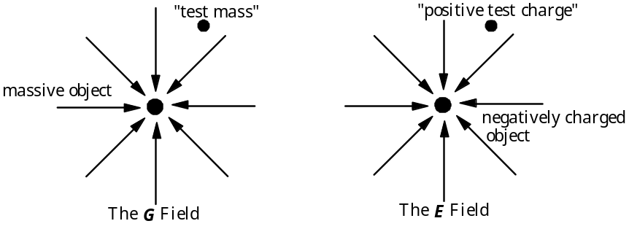
Figure 1. A comparison of G and E fields
Q1[10’] Draw an arrow on the "test mass" and on the "positive test charge" in Figure 1 to indicate the direction of the force on each of those objects. Explain how you found which way the arrow should point.
___________________________________________________________
___________________________________________________________
___________________________________________________________
Q2[10’] Consider the expression for electrical potential energy in your textbook. For the gravitational field, the potential energy is higher when the distance between two interacting masses is greater. Is this also true for the electrical potential energy of two interacting charges?[2’] Why?[8’]
___________________________________________________________
___________________________________________________________
___________________________________________________________
___________________________________________________________

Q3[10’] Two like or unlike point charges are separated by a distance r, as shown below. Assume the potential energy is zero when the charges are very far apart, and plot the potential energy vs. r for each case from r=0 to a very large r.
P.E.
r
P.E.
r
+
+
r
+
-
r

Q4[10’] Explain the difference between electrical potential energy and electric potential difference.
___________________________________________________________
___________________________________________________________
___________________________________________________________
Q5[10’] Batteries always have two terminals, labeled + and -. The + terminal has the higher electric potential. If you connected the terminals to a circuit, which way would positive charges flow in the circuit?[5’] What about negative charges?[5’]
___________________________________________________________
___________________________________________________________
___________________________________________________________

